
Test Case Design Assignment
Intelligent Airport Baggage Tracking and Logistics Management Platform
CSA1016-SOFTWARE ENGINEERING

Name: K.Arthika Reddy
Regno:192373033
Department:CSE(DS)

1. Testing Strategy

The Intelligent Airport Baggage Tracking and Logistics Management Platform handles real-time baggage tracking data, RFID/barcode scanning, baggage routing, conveyor-belt movement, flight information, AI-based predictions, baggage status updates, and passenger notifications. Therefore, a comprehensive testing strategy is required to ensure correctness, performance, security, and reliability.

1.1 Unit Testing

Unit testing verifies individual software components independently.

Components to test:
- Passenger registration and login
- Baggage registration module
- Baggage ID generation
- RFID/barcode scanning module
- Baggage status calculation
- Baggage tracking module
- Flight and baggage-assignment module
- Baggage routing algorithm
- Lost baggage detection
- Delay prediction algorithm
- Notification service
- Admin dashboard
- Logistics management module

Example:

Verify that when an RFID scanner detects a baggage tag, the corresponding baggage status changes from Registered to Checked-In.

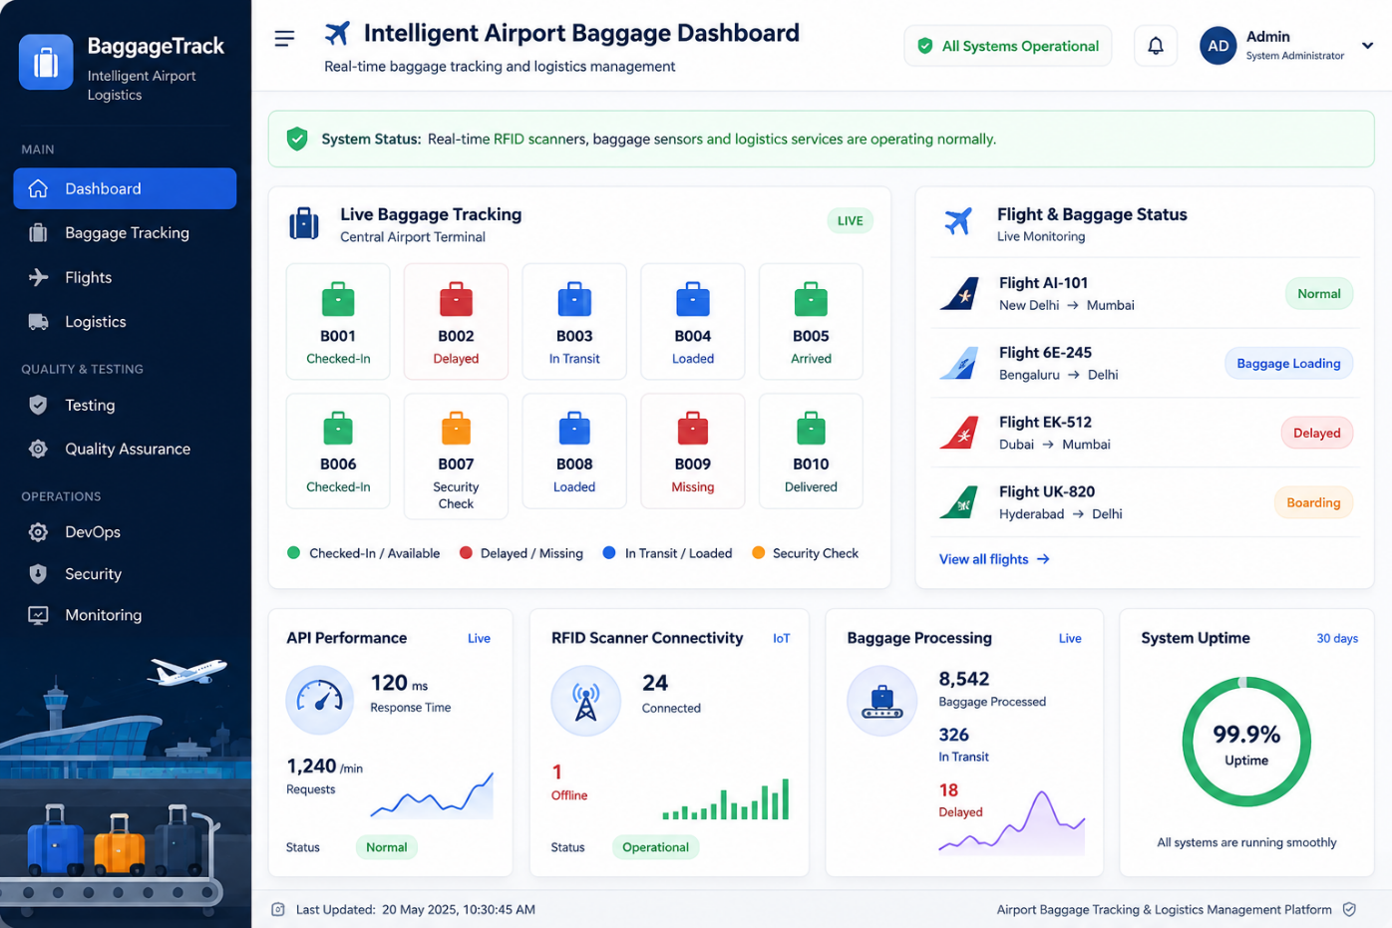

1.2 Integration Testing

Integration testing verifies communication between different modules.

Important integration tests:
- RFID/Barcode scanners → Backend server
- Conveyor sensors → Baggage tracking service
- Backend → Database
- Backend → Mobile/Web application
- Flight management system → Baggage assignment service
- AI prediction service → Baggage logistics service
- Baggage tracking service → Notification service
- Authentication service → User management
- Baggage handling system → Airport logistics service

1.3 System Testing

System testing validates the complete platform as a single system.

The following scenarios should be tested:
- Passenger registers baggage.
- System generates a unique baggage ID.
- Baggage is checked in at the airport.
- RFID/barcode scanner detects the baggage.
- System updates baggage status.
- Baggage is assigned to the correct flight.
- Baggage is routed through the appropriate conveyor belt.
- Passenger receives baggage-status notifications.
- System detects delayed or misplaced baggage.
- System recommends an alternative logistics route or handling action.

1.4 Performance Testing

Performance testing ensures that the platform can process large amounts of real-time baggage data.

Tests should measure:
- API response time
- Number of simultaneous users
- RFID/barcode scanning processing rate
- Number of baggage records processed per second
- Database query performance
- Baggage-location update time
- Notification delivery time
- AI prediction response time
- Server CPU and memory utilization
- Conveyor/sensor data processing rate

The system should maintain acceptable response times even during peak airport hours when thousands of passengers and baggage items are being processed simultaneously.

1.5 Load and Stress Testing

Load testing evaluates the platform under expected airport traffic conditions, while stress testing determines the point at which the system becomes unstable.

Example scenarios:
- Thousands of passengers tracking baggage simultaneously.
- Large numbers of baggage items being scanned continuously.
- Multiple airport terminals sending baggage data simultaneously.
- Large numbers of baggage registrations during peak hours.
- Sudden increase in baggage-tracking requests.
- Multiple RFID scanners transmitting data at the same time.
- Large numbers of flight-related baggage updates.

1.6 Security Testing

Security testing protects passenger information, baggage details, flight information, authentication credentials, and communication between airport devices and servers.

Security tests should include:
- Authentication testing
- Authorization testing
- SQL injection testing
- Cross-Site Scripting (XSS) testing
- API security testing
- Password security testing
- Session-management testing
- Encryption verification
- RFID/device authentication
- Protection against unauthorized baggage-data access
- Secure payment or service-related information handling where applicable

1.7 Usability Testing

The mobile and web interfaces should be simple and easy to use for passengers, baggage handlers, airport employees, and administrators.

Usability testing should verify:
- Easy registration and login
- Simple baggage registration
- Easy baggage tracking
- Clear baggage-status indicators
- Simple baggage search
- Understandable airport navigation
- Accessible notifications
- Clear flight and baggage information
- Easy-to-use admin dashboard

2. Sample Test Cases
Test Case ID | Test Scenario | Input | Expected Result
TC01 | User Login | Valid username and password | User successfully logs in
TC02 | Invalid Login | Incorrect password | Error message displayed
TC03 | Baggage Registration | Passenger baggage details | Baggage registered successfully
TC04 | Baggage ID Generation | New baggage registration | Unique baggage ID generated
TC05 | RFID Scan | Valid RFID tag | Baggage identified successfully
TC06 | Baggage Status Update | Baggage scanned at checkpoint | Status updated correctly
TC07 | Flight Assignment | Baggage and flight details | Baggage assigned to correct flight
TC08 | Baggage Routing | Baggage detected at conveyor | Correct route/conveyor recommended
TC09 | Notification | Baggage status changed | Passenger receives notification
TC10 | Unauthorized API Access | Invalid authentication token | Access denied
TC11 | High Load | Multiple simultaneous requests | System remains responsive
TC12 | Scanner Failure | Scanner stops sending data | Failure detected and administrator alerted
TC13 | Lost Baggage Detection | Baggage not detected at expected checkpoint | System identifies possible missing baggage
TC14 | Baggage Arrival | Baggage reaches destination belt | Status changes to Arrived
TC15 | Baggage Collection | Passenger collects baggage | Status changes to Collected

3. Quality Assurance

Quality assurance ensures that the software satisfies functional and non-functional requirements throughout the development lifecycle.

QA Activities
- Requirement validation
- Code reviews
- Coding standards
- Unit and integration testing
- Automated testing
- Security testing
- Performance testing
- Regression testing
- User acceptance testing
- Defect tracking
- Documentation review
- RFID/scanner integration testing

Quality Metrics

The following metrics can be monitored:
- Test case pass percentage
- Defect density
- Code coverage
- API response time
- Baggage-tracking accuracy
- System uptime
- Baggage processing failure rate
- Mean Time Between Failures (MTBF)
- Mean Time To Recovery (MTTR)
- Security vulnerability count
- Notification delivery success rate

Continuous monitoring of these metrics helps maintain software quality.

4. DevOps Practices

DevOps integrates development and operations to enable faster, safer, and more reliable software delivery.

4.1 Version Control

Git and GitHub can be used to manage source code.

A recommended branch structure is:
- main – production-ready code
- develop – integration branch
- feature/* – individual features
- bugfix/* – bug fixes

Developers should use pull requests and code reviews before merging changes.

4.2 Continuous Integration

A CI pipeline automatically builds and tests every code change.

CI Process:

Developer

↓

Git Commit

↓

GitHub Repository

↓

Build Application

↓

Run Unit Tests

↓

Run Integration Tests

↓

Security Scan

↓

Quality Check

If any critical test fails, the build should be rejected.

4.3 Continuous Deployment

After successful testing, the application can be deployed automatically to the target environment.

Code

↓

Build

↓

Test

↓

Security Scan

↓

Docker Image

↓

Deployment

↓

Monitoring

Docker containers can be used to package backend services, databases, AI services, and baggage-processing components consistently.

4.4 Infrastructure and Monitoring

The platform should continuously monitor:
- CPU utilization
- Memory utilization
- API response time
- Database performance
- RFID/scanner connectivity
- Conveyor sensor connectivity
- Application errors
- Network traffic
- Service availability
- Baggage-processing failures

Alerts should be generated when abnormal conditions occur.

5. Security Design

Security is critical because the platform handles passenger accounts, baggage information, flight details, location information, and airport IoT devices.

Security Measures

Authentication:
Use secure login mechanisms and strong password policies.

Authorization:
Implement role-based access control for passengers, baggage handlers, airport staff, and administrators.

Data Encryption:
Sensitive information should be encrypted during transmission and storage.

Secure APIs:
APIs should use authentication tokens and validate all incoming requests.

Database Security:
Use parameterized queries, access controls, backups, and encryption where appropriate.

IoT Security:
Each RFID scanner, barcode scanner, and IoT device should be authenticated before transmitting baggage information.

Network Security:
Use secure communication protocols and firewall controls.

Privacy Protection:
Collect only the information required for baggage tracking and logistics operations and restrict access to sensitive data.

6. Reliability and Fault Tolerance

The platform must remain operational even when individual components fail.

Reliability Mechanisms
- Database backup and recovery
- Redundant servers
- Health monitoring
- Automatic service restart
- Fault detection
- RFID/scanner failure detection
- Error logging
- Retry mechanisms
- Load balancing
- Disaster recovery procedures
- Backup communication mechanisms

For example, if an RFID scanner stops working, the system should identify the failure and notify the administrator instead of continuously displaying outdated baggage-location information as accurate real-time data.

Availability

The platform should be designed for high availability because passengers and airport staff depend on current baggage information.

Critical services should have redundancy so that failure of one service does not bring down the entire baggage-tracking platform.

7. Ethical Considerations

The system uses RFID scanners, IoT devices, passenger information, location data, and AI analytics. Therefore, ethical issues must be addressed.

7.1 Privacy

The platform should avoid unnecessary collection of personally identifiable information. Passenger, baggage, and location data should only be collected when necessary and handled securely.

7.2 Transparency

Users should be informed about:
- What data is collected
- Why the data is collected
- How the data is used
- How long it is retained
- Who can access the information

7.3 Responsible AI

AI-based baggage-delay, routing, and lost-baggage predictions should be regularly evaluated for accuracy and bias.

The system should not unfairly prioritize certain passengers or baggage without a valid operational reason.

7.4 Surveillance

Airport monitoring systems should be used only for legitimate security and baggage-management purposes. Access to surveillance and tracking data should be restricted to authorized personnel.

7.5 Data Protection

Passenger and baggage information should not be unnecessarily shared with third parties. Appropriate retention and deletion policies should be implemented.

7.6 Accessibility and Fairness

The platform should be accessible to passengers and airport employees with different levels of technical ability and should provide clear baggage and flight information without unfairly excluding particular groups.

8. Overall Quality and DevOps Architecture

USERS

|

↓

Mobile / Web Application

|

↓

API Gateway

|

--------------------------------

| | |

↓ ↓ ↓

User Service Baggage Service Flight Service

|

↓

Logistics Service

|

↓

AI Analytics

|

-------------------------------

| |

↓ ↓

Baggage Prediction Route Optimization

| |

---------------+--------------

|

↓

Database

|

-------------------------------

| | |

↓ ↓ ↓

RFID Scanners Barcode Scanners IoT Sensors

|

↓

Real-Time Baggage Data Processing

DevOps Pipeline

Git Repository

↓

Build & Test

↓

Security Scan

↓

Docker Build

↓

Deployment

↓

Monitoring

9. Expected Result

The proposed testing, QA, DevOps, security, reliability, and ethical framework ensures that the Intelligent Airport Baggage Tracking and Logistics Management Platform is:
- Secure against unauthorized access and common attacks.
- Reliable during scanner, network, database, or service failures.
- Scalable for multiple airport terminals and large baggage volumes.
- Performant during peak airport operations.
- Accurate in tracking baggage locations and status.
- Maintainable through automated testing and CI/CD.
- Privacy-aware in its handling of passenger and baggage data.
- Efficient in baggage routing and logistics management.
- Ethically responsible in the use of AI, IoT, and passenger data.

